- Challenge Name and Category: PIE TIME (Binary Exploitation)

- Difficulty/Points: Easy

- Description: Can you try to get the flag? Beware we have PIE!Connect to the program with netcat: $ nc rescued-float.picoctf.net 62375
The program's source code can be downloaded here. The binary can be downloaded here.

- Flag: picoCTF{b4s1c_p051t10n_1nd3p3nd3nc3_28a46dcd}

- Solution/Walkthrough: We are given a command to connect through the program via net cat. After running this command, we are given the following information, of main () on the server. We need the min() to discover the flag. The issue is when a program gets loaded to PIE, it gets loaded to a random address within the memory.
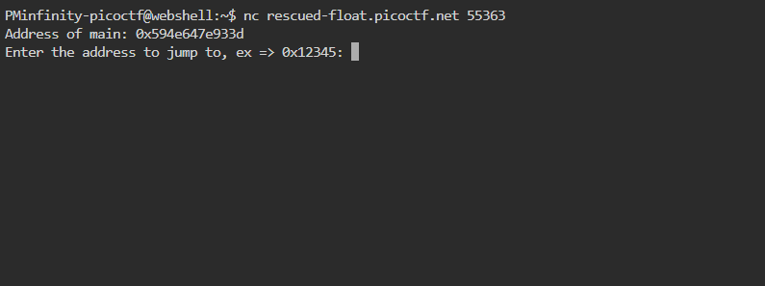
Looking at the source code we can see the win() appearing close to the stop of the code. I used notepad to view the code in plain text. Next, we need to download the binary file by using the wget command in the web shell.
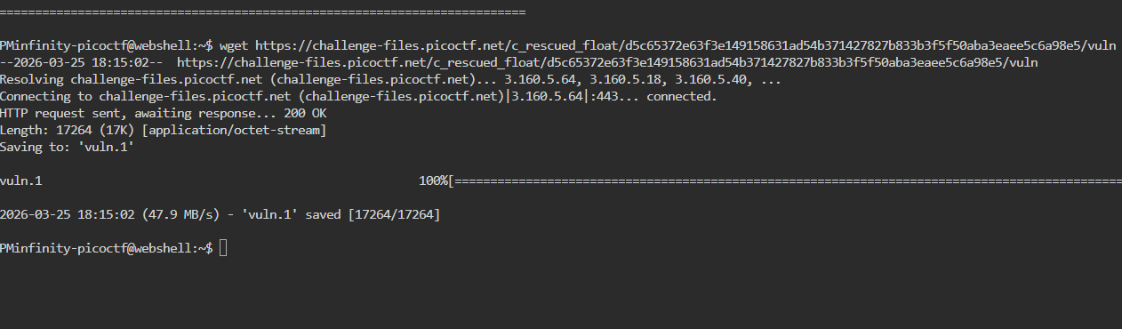
Now I sudo installed the GNU debugger and ran the command gdb vuln. Afterwards I needed to find the location of some functions in the binary GDB. To do this I issue the command x main and x win. After obtaining the hex values of win and min we will subtract them using a hex calculator.
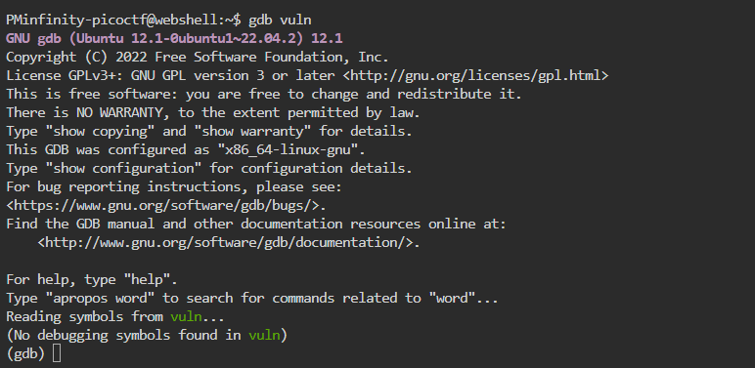
Subtracting the hex values from one another we get a hex value of 96.
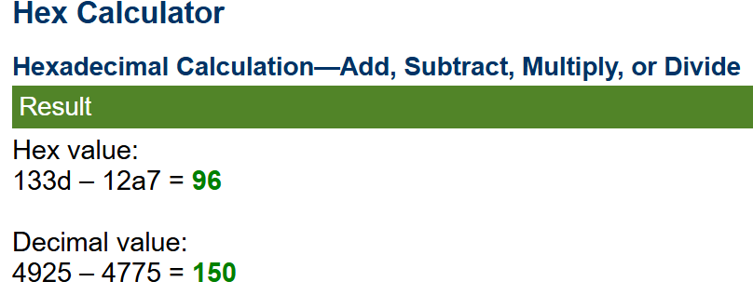
Now that the hex value is obtained, we will access the program via netcat once more. Once we connect well get the hex value of the address of main and subtract it from the offset value we obtained, 96.
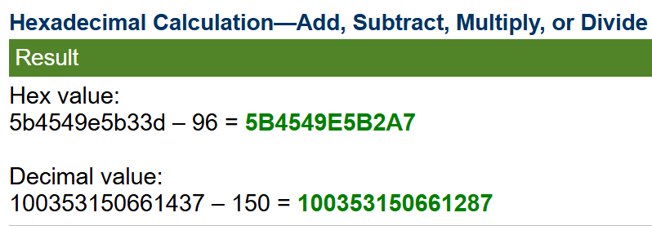
This results in a new hex value, min(), that is the location of the flag. I will enter this address to take me to the flag.
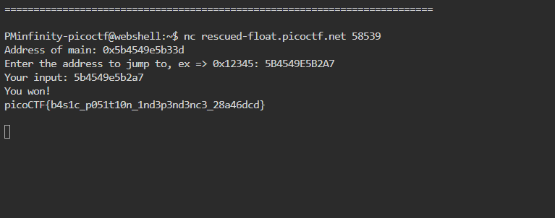
- Tools Used: web shell, note pad, GNU debugger.

- Initial Reconnaissance: I needed to research the win() and main() functions as well as the mathematics behind the hex values.

- Hypothesis Formulation: After understanding I how to get the main function I needed to figure out and research what to do to obtain the win()

- What Worked vs. What Didn't: It took a while to understand the main() and win(). It was also the first time I used the GNU debugger. Subtracting hex values was a new process as well. This CTF was a great learning experience for me.

